**Chapter 5 Summary**

**Importance of Human Resource Management (HRM)**

* As a necessary part of the organizing function of management
  + Selecting, training, and evaluating the work force
* As an important strategic tool
  + HRM helps establish an organization’s sustainable competitive advantage.
* Adds value to the firm
  + High performance work practices lead to both high individual and high organizational performance.

**Functions of the HRM Process**

* + Ensuring that competent employees are identified and selected.
  + Providing employees with up-to-date knowledge and skills to do their jobs.
  + Ensuring that the organization retains competent and high-performing employees who are capable of high performance.

**Human Resource Inventory**

* + A review of the current make-up of the organization’s current resource status

**Job Analysis**

An assessment that defines a job and the behaviors necessary to perform the job. Requires conducting interviews, engaging in direct observation, and collecting the self-reports of employees and their managers.

**Knowledge, Skills, and Abilities (KSAs)**

**Knowledge** – Knowledge is a familiarity, awareness, or understanding of someone or something, such as facts, information, descriptions, or skills, which is acquired through experience or education by perceiving, discovering, or learning. Knowledge can refer to a theoretical or practical understanding of a subject.

**Skills** - The ability to do something well; expertise.

**Abilities** - Talent, skill, or proficiency in a particular area.

**Difference between Job Description and Job Specification**

|  |  |
| --- | --- |
| **Job Description** | **Job Specification** |
| A written statement of what the job holder does, how it is done, and why it is done. | A written statement of the minimum qualifications that a person must possess to perform a given job successfully. |

**Comparing Recruitment, Decruitment and E-Recruiting**

|  |  |  |
| --- | --- | --- |
| Recruitment | Decruitment | E-Recruiting |
| Process of locating, identifying, and attracting capable applicants to an organization | The process of reducing a surplus of employees in the workforce of an organization | Recruitment of employees through the Internet   * Organizational web sites * Online recruiters |

**Sources of Potential Job Candidates**

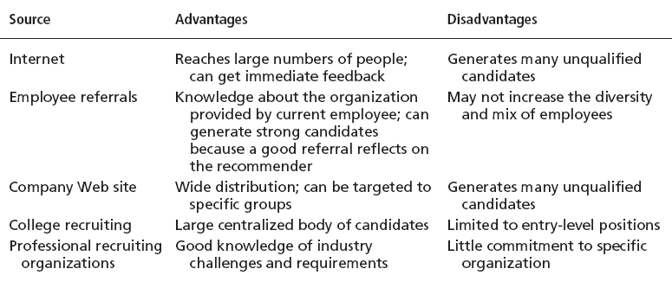

**Selection**

* Choosing the best choice among the given candidates which is measured via certain criteria and evaluation process.

**Selection Process**

* Involves various protocols and steps in the selecting of the candidate.

**Selection errors**

* + - Reject errors for potentially successful applicants
      * Happens when there are too many candidates with the same level of qualifications and experience
    - Accept errors for ultimately poor performers
      * This happens upon hiring of the candidate who fails to deliver and meet the expectation.

**Validity & Reliability**

|  |  |
| --- | --- |
| **Validity** | **Reliability** |
| Validity is the extent to which a concept, conclusion or measurement is well-founded and likely corresponds accurately to the real world. | Reliability in statistics and psychometrics is the overall consistency of a measure. A measure is said to have a high reliability if it produces similar results under consistent conditions. |

**Types of Devices which are commonly used for the selection process**

* Application Forms
* Written Tests
* Performance Simulations
* Interviews
* Background Investigations
* Physical examinations

**Aptitude Vs Attitude**

|  |  |
| --- | --- |
| **Aptitude** | **Attitude** |
| A natural ability to do something. | a feeling or opinion about something or someone, or a way of behaving that is caused by this |

**Orientation**

An introductory stage in the process of new employee assimilation, and a part of his or her continuous socialization process in an organization.

Major objectives of orientation are to

(1) gain employee commitment

(2) reduce his or her anxiety

(3) help him or her understand organization's expectations

(4) convey what he or she can expect from the job and the organization.

**Types of Orientation**

|  |  |
| --- | --- |
| Work Unit | Organisation |
| Familiarizes new employee with work-unit goals  Clarifies how his or her job contributes to unit goals  Introduces he or she to his or her coworkers | Informs new employee about the organization’s objectives, history, philosophy, procedures, and rules.  Includes a tour of the entire facility |

**Training**

Organized activity aimed at imparting information and/or instructions to improve the recipient's performance or to help him or her attain a required level of knowledge or skill.

**Types of Training**

**General**

* Common Trainings that are required to be known by all employees in the organization

**Specific**

* This focus to only a certain scope of areas which is only given to certain employees depending on which department they come from

**Methods of Training**

1. **Traditional Based**

* This uses the traditional approach of face to face and manual based approach which may include on the job training, mentoring and coaching.

1. **Technology Based**

* Involves the usage of various technologies from computers to stimulate and enhances the training process.